Software Requirements Specification
for
ShopEasy Online Store
Prepared by Sarah Johnson, Michael Chen, Emily Rodriguez
Organization: TechCommerce Solutions
Date Created: 02/11/2026

Table of Contents

[Note: The Table of Contents will be automatically generated when you open this document in Microsoft Word. If it doesn't appear, right-click and select 'Update Field']

1. Introduction

1.1 Purpose
The purpose of ShopEasy Online Store is to provide an affordable platform for small retailers to sell products online with integrated payment processing and inventory management.

1.2 Intended Audience
This document is intended for:
- Admin
- Manager
- Customer
- Development Team
- Stakeholders

1.3 Project Scope

Included in scope:
- User registration and login
- Product catalog with search and filters
- Shopping cart management
- Checkout with Stripe payment
- Order tracking
- Product reviews and ratings
- Admin inventory dashboard
- Email notifications

Excluded from scope:
- Hardware manufacturing
- Third-party marketing services

1.4 Document Conventions
- Standard IEEE formatting
- Bold text for UI elements

1.5 References
- GDPR: General Data Protection Regulation
- HIPAA: Health Insurance Portability and Accountability Act

2. Overall Description

2.1 Product Perspective
ShopEasy Online Store is a standalone AI/ML System for the E-commerce sector, designed to provide an affordable platform for small retailers to sell products online with integrated payment processing and inventory management.

2.2 Product Features
- User registration and login
- Product catalog with search and filters
- Shopping cart management
- Checkout with Stripe payment
- Order tracking
- Product reviews and ratings
- Admin inventory dashboard
- Email notifications

2.3 User Classes and Characteristics

Admin
- Tech-savvy
- Frequent use for inventory management and order tracking

Manager
- Moderately tech-savvy
- Regular use for managing products and orders

Customer
- Variable tech-savviness
- Occasional use for browsing and purchasing products

2.4 Operating Environment
- Web-based application
- Mobile-responsive design
- Python backend

2.5 Design and Implementation Constraints
- Preferred backend: Python
- Database preference: Any
- Deployment preference: Any
- Compliance requirements: GDPR, HIPAA

2.6 User Documentation
- User Manual
- API Documentation

2.7 Assumptions and Dependencies

Assumptions:
- Users have basic computer skills
- Internet connection is available

Dependencies:
- Stripe payment gateway
- Python libraries and frameworks

3. System Features

3.1 User Registration and Login
Description: Manages user accounts and authentication.

Stimulus/Response Sequences:
Stimulus: User submits registration form
Response: System creates a new user account and sends a confirmation email.
Stimulus: User logs in with valid credentials
Response: System authenticates the user and redirects to the dashboard.

Functional Requirements:
- The system shall validate user input data during registration.
- The system shall store user credentials securely.

3.2 Product Catalog with Search and Filters
Description: Displays products with filtering and search capabilities.

Stimulus/Response Sequences:
Stimulus: User searches for products
Response: System displays a list of matching products.
Stimulus: User applies filters
Response: System updates the product list based on filter criteria.

Functional Requirements:
- The system shall retrieve product data from the database.
- The system shall apply filters and sorting to product listings.

3.3 Shopping Cart Management
Description: Manages products added to the cart.

Stimulus/Response Sequences:
Stimulus: User adds a product to cart
Response: System updates the cart contents and displays the updated cart.
Stimulus: User removes a product from cart
Response: System updates the cart contents and displays the updated cart.

Functional Requirements:
- The system shall store cart contents in the user's session.
- The system shall calculate the total cost of items in the cart.

3.4 Checkout with Stripe Payment
Description: Handles payment processing with Stripe.

Stimulus/Response Sequences:
Stimulus: User submits payment information
Response: System processes payment with Stripe and updates order status.

Functional Requirements:
- The system shall integrate with Stripe for payment processing.
- The system shall handle payment success and failure scenarios.

3.5 Order Tracking
Description: Allows users to track their orders.

Stimulus/Response Sequences:
Stimulus: User requests order status
Response: System displays the current order status and tracking information.

Functional Requirements:
- The system shall store order status and tracking information.
- The system shall update order status in real-time.

3.6 Product Reviews and Ratings
Description: Manages product reviews and ratings.

Stimulus/Response Sequences:
Stimulus: User submits a product review
Response: System publishes the review and updates the product rating.

Functional Requirements:
- The system shall store product reviews and ratings in the database.
- The system shall display product reviews and ratings on the product page.

3.7 Admin Inventory Dashboard
Description: Provides an inventory management interface for admins.

Stimulus/Response Sequences:
Stimulus: Admin logs in and navigates to the inventory dashboard
Response: System displays the inventory dashboard with product listings and management options.

Functional Requirements:
- The system shall retrieve inventory data from the database.
- The system shall allow admins to manage products and inventory levels.

3.8 Email Notifications
Description: Sends email notifications to users.

Stimulus/Response Sequences:
Stimulus: System triggers an email notification
Response: System sends an email to the relevant user or admin.

Functional Requirements:
- The system shall integrate with an email service provider.
- The system shall handle email sending failures and retries.

External Interface Requirements for ShopEasy Online Store

User Interfaces
This section describes the user interfaces for the ShopEasy Online Store, including user interaction flows, validations, and error handling.

User Interface Architecture:
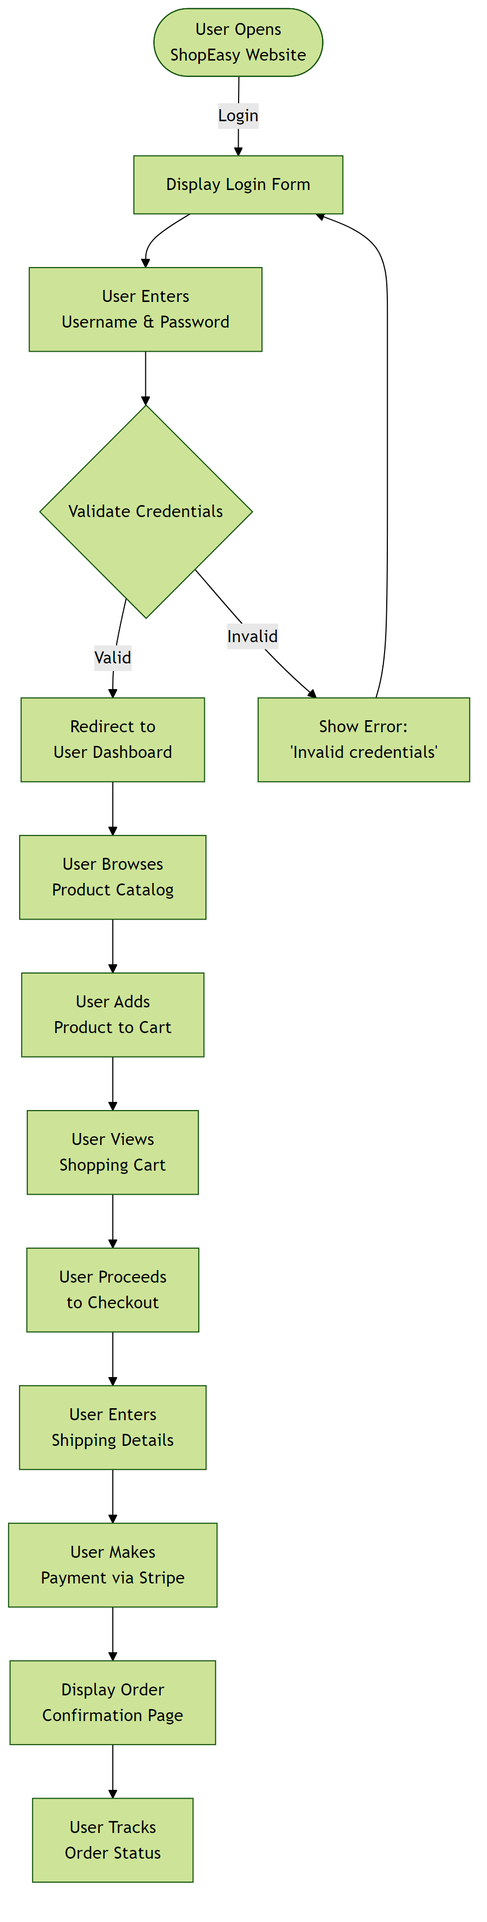

Hardware Interfaces
This application is a cloud-native web system with no direct hardware integrations. All operations are performed through web browsers and standard computer hardware (keyboard, mouse, display) without requiring specialized hardware devices.

Hardware Interface Architecture:
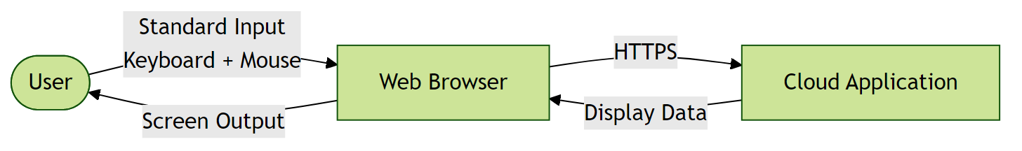

Software Interfaces
This section describes the software interfaces for the ShopEasy Online Store, including external API integrations and database interactions.

Software Interface Architecture:
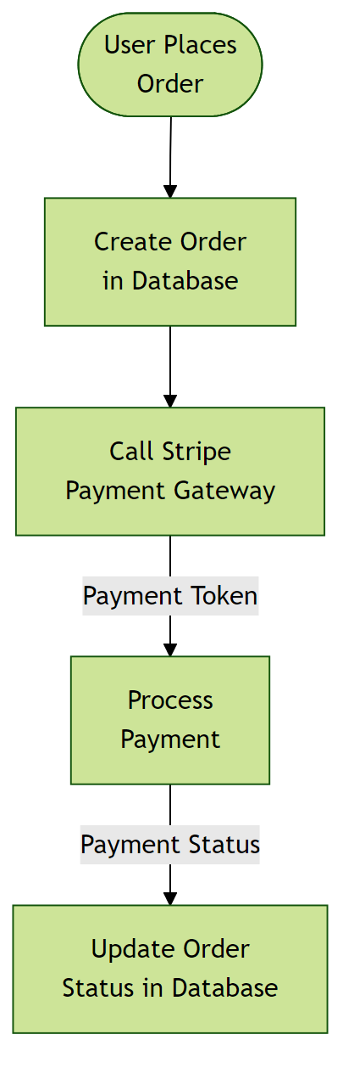

Communication Interfaces
This section describes the communication interfaces for the ShopEasy Online Store, including network protocols and security measures.

Communication Interface Architecture:
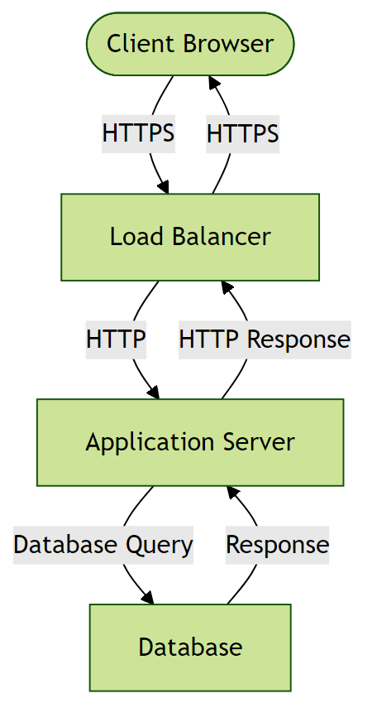

5. Non-Functional Requirements

5.1 Performance Requirements
- The system shall support at least 100 concurrent users without performance degradation.
Rationale: To accommodate the expected user scale of less than 100 users.
- The system shall respond to user requests within 2 seconds under normal load.
Rationale: To ensure a responsive user experience.

5.2 Safety Requirements

5.3 Security Requirements
- The system shall implement authentication for all users.
Rationale: To ensure that only authorized users can access the system.
- The system shall comply with GDPR and HIPAA regulations.
Rationale: To protect sensitive user information and meet regulatory requirements.

5.4 Quality Attributes
- The system shall achieve 99.9% uptime.
Rationale: To ensure high availability for users.
- The system shall be maintainable with modular architecture and comprehensive documentation.
Rationale: To enable efficient updates and reduce long-term maintenance costs.

6. Glossary

6.1 Technical Terms
AI/ML System: Artificial Intelligence/Machine Learning System - a system that uses AI and ML technologies to perform tasks.
E-commerce: Electronic Commerce - the buying and selling of goods and services over an electronic network, typically the internet.
Stripe: Stripe - a payment gateway used for processing online payments.
Python: Python - a high-level, interpreted programming language used for developing the backend of the system.
API: Application Programming Interface - a set of protocols and tools for building software applications.

6.2 Acronyms and Abbreviations
GDPR: General Data Protection Regulation - a regulation in EU law on data protection and privacy.
HIPAA: Health Insurance Portability and Accountability Act - a US law designed to provide privacy standards to protect medical records.
NFR: Non-Functional Requirements - operational constraints defining system performance, security, and quality.

6.3 System Components
Authentication Service: Component responsible for verifying user credentials and managing access tokens.
Database Layer: Persistent storage layer managing data operations and ensuring data integrity.
Cloud-based Infrastructure: Infrastructure that uses cloud computing to provide scalable and on-demand access to resources.

6.4 Technologies
Cloud Service Providers: Third-party services that provide cloud-based infrastructure for deployment and scaling.
Python Libraries and Frameworks: Pre-built software components that provide functionality for Python applications.

6.5 Performance Metrics
Concurrent Users: Number of users actively using the system simultaneously without performance degradation.
Response Time: Time elapsed between a user request and the system's response.
Uptime: Percentage of time the system is operational and accessible, typically expressed as 99.9% or similar.

6.6 Security Terms
Authentication: Process of verifying the identity of a user or system.
Authorization: Process of determining whether a user has access to a particular resource or functionality.
Encryption: Process of converting plaintext data into unreadable ciphertext to protect it from unauthorized access.

6.7 Quality Attributes
Reliability: Ability of the system to perform its required functions under normal operating conditions.
Scalability: Ability of the system to handle increased load or demand without decreasing performance.
Maintainability: Ease with which the system can be maintained, updated, or modified.

7. Assumptions

Assumption 1:
Users will have basic computer skills and familiarity with web-based applications.
Impact: If users lack basic digital skills, additional training programs and simplified UI/UX would be required, increasing project costs and extending the rollout timeline.

Assumption 2:
An internet connection with a minimum speed of 5 Mbps will be available for users.
Impact: Insufficient internet bandwidth could lead to poor system performance, user dissatisfaction, and potential failures in real-time data synchronization.

Assumption 3:
The Stripe payment gateway will be available and maintain backward compatibility throughout the project lifecycle.
Impact: Breaking changes in the Stripe API would require immediate integration updates, potentially causing system downtime and delaying feature releases.

Assumption 4:
The third-party email service provider will have an uptime of 99.9% and will not have any major disruptions.
Impact: Email service disruptions could affect user communication, leading to missed notifications and a negative impact on user experience.

Assumption 5:
The system will be deployed on infrastructure that can scale to accommodate at least 100 concurrent users.
Impact: Inadequate infrastructure scalability could result in performance degradation, slow response times, and potential system crashes under heavy load.

Assumption 6:
Regulatory requirements for data privacy (GDPR, HIPAA) will remain stable during development.
Impact: Changes in data privacy regulations could necessitate significant architectural changes, additional compliance features, and potential project delays.

Assumption 7:
The organization will have an existing infrastructure that can be integrated for user authentication.
Impact: Without existing infrastructure integration, the project would require building a custom authentication system, increasing development time and ongoing maintenance overhead.

Assumption 8:
Business stakeholders will be available for weekly requirement reviews and timely decision-making.
Impact: Lack of stakeholder availability could lead to requirement ambiguities, implementation delays, and potential rework due to misaligned expectations.

Assumption 9:
The database server will have at least 500GB of available storage with capacity to expand.
Impact: Insufficient storage capacity would limit data retention capabilities and could cause system failures if storage limits are reached unexpectedly.

